**Automated detection of COVID-19 cases using deep neural networks with X-ray images**

**Prathmesh bhosale**

**SMST,Indian Institute Of Technology ,Khargpur,India.**

**Abstract**

This is an implemented project from the original paper "Automated detection of COVID-19 cases using deep neural networks with X-ray images". As we all know, the world was going through a dire situation of the coronavirus , which was first appeared in Wuhan city in china in 2019. Its spreads in the whole world quickly and become an epidemic to pandemic. It has caused severe health issues, economic issues all over the world. Our goal is to detect the positive cases as early as possible, treat the patients, and stop the vast spread of this disease. Because of no accurate automated kit available, there is the need for an alternative automatic method to come and give accurate results. By looking at the X-ray images, scientists have recognized the noticeable feature of this disease in these images. Neural networks and their application joint with radiological imaging would be a perfect solution for this problem of lack of expert physicians in the remote area or small clinical ecosystems; in this study, the author has developed a model for the automatic detection of covid 19 using bare chest Xray images by using DarkNet framework as a classifier for state of the art YOLO real-time object detection system. Here they have implemented 17 layers of convolution by modifying DarkNet 19 architecture. This new model presented promises to deliver the very accurate result as accurate as 99.62% in the binary class classification of covid vs no finding and 93.75% accuracy for multi-class cases (covid vs no finding vs Pneumonia) and 94% accuracy for 4 class (covid vs no finding vs Pneumonia vs lung opacity); our model can give extra pairs of eyes to the radiologist and help them in validating there first screening and also can be used in immediately screening of patients.

**1. Introduction**

coronavirus disease started reporting from the Wuhan city in china in late December 31 has rapidly become pandemic. The virus in this disease was known as SARS-CoV-2 and had spread in the Wuhan city in nearly 30 days . Then in the US first 7 cases were reported on the last week of Jan 2020 and reached over 253,420,051 till November 13, November 13, 2021. This SARS-Cov and MERS-Cov cause severe fatigue, respiratory disease, and death[6] in human beings .fever, cough, sore throat, headache, shortness of breath, fatigue, and muscle pain are the clinical conditions that happen in this disease[1-7].

The kit 'RT-PCR' (reverse transcription-polymerase chain reaction) was developed in the chain to test covid with the radiological images of the chest such as CT or X-ray has their vital role in the very early diagnosis and care. But there is a significant issue with the kit: the low sensitivity of 65 to70% for negative testes and the symptoms were seen. The patient affected by the disease was seen in the radiological imagining like X-ray or CT, So on the basis of this, it is stated that CT is a sensitive method to detect the variation and the salient damage formed by the virus . The patient encountered have standard CT in the first two days in initial variants. The most significant lung infection was observed in the ten days after the illness. Because of the false reading of the kit, clinicians are encouraged to make a diagnosis on the basis of the CT results. Still, there is one problem with the CT that is it requires a time of expert physicians, so it was initially done where there is low no of cases were getting like in the city of turkey. Combining ct images with the lab results would be the best diagnostics. In the later stage, it was observed that before the symptoms also changes occurred in the x-ray and ct images . By the contribution of numerous radiologists and physicists, it is followed by largely infrahilar airspace opacities, one in 3 patients have single nodular opacity in the lower lung, GGO(ground-glass opacities) in both lung, interlobular septal thickening and air bronchogram sign with or without vascular expansion were the main CT and Xray features[8-17].

Recently the application of deep learning (which is the research area in artificial intelligence) in the field of automatic medical diagnosis gained popularity and has become a handy tool for clinicians to reduce their work drastically; the good thing about deep learning is automatic feature extraction, and it also helps to create end to end models which only needs the clinical data process and to make models. Earlier than covid deep learning technique used in many diseases like arrhythmia detection, skin cancer classification, breast cancer detection, brain disease classification, lung segmentation, etc. [26-35]. Because of covid 19 rapid rise its need to have a look into this field to diagnose the patients as fast as possible by automated detection system by using AI technology [36-39].with the limited no of radiologists its challenging task to see all the images by the radiologists, therefore simple easy to use AI models are helpful to overcome this crisis[40], with the integration of radiologists and deep learning researchers we can develop this model and improve it in the coming months . this model can be useful where we have less RT-PCR kits, test cost, and waiting for results.

Recently, many scientists have come up with there models to classify covid 19 detection. Hemdan et al. used the COVIDX-Net model comprising 7 CNN models, of which we're giving 90% accuracy. Wang and Wong proposed a deep learning model, COVID-Net, showing an accuracy of 92.4% in classifying regular, non-COVID Pneumonia, and COVID 19. Ioannis et al. made a model with 224 confirmed cases using VGG 19 and obtained an accuracy of 98.75% in binary class and 93.48% in 2 and 3 classes, but the data was not that big, Narin et al. got 98% accuracy by ResNet50 model. Sethy and Behera classify with the help of CNN and support vector machine (SVM). So this was several recent studies, and now we will be looking at our contribution.

The author of this study is proposing a deep learning model for automatic covid 19 detection. The proposed model has end to end architecture without using any manual feature extraction methods. The only required input is the bare chest x-ray images for the patient whose diagnosis we want. The goal is to get accuracy as high as possible and focus on the point that is not noticeable to the human eye for classification accuracy.

The new model that we proposed is called as 'DarkCovidNet' model, which is made by modifying the DarkNet-19 model. This DarkNet-19 model has 19 convolution layers that are why its called DarkNet-19, and it has some unique architecture which is described in the diagram below Fig 3 and in the proposed model, we have a total of 17 convolution layers, and it will be further described in the details in the proposed study part section.

**2. Material: X-ray image Data set**

In the starting, the Xray dataset was developed by Cohen JP using various open sources. The database was updated from the different regions in the world every day. But I have taken the data set from the COVID-19 Radiography Database presented in Kaggle (https://www.kaggle.com/tawsifurrahman/covid19-radiography-database this dataset was obtained by a team of researchers from Qatar University, Doha, Bangladesh, Malaysia, Pakistan in collaboration with medical experts and made Covid vs normal vs Viral Pneumonia images, this is the second update in which there are 3616 covid images,10192 standard images,1345 pneumonia (some are taken from Mendeley data) images,6012 lung opacity images ) I have downloaded this in my Gdrive for the implementation. Then I made a new folder by myself, one for multi-class (covid vs regular vs Pneumonia) and (covid vs regular vs Pneumonia vs lung opacity) . One for binary (covid vs regular), each had a training folder which contains 1000 images in each subfolder and the testing set 400 images in each subfolder. Images were taken randomly to avoid the unbalance data problem. Fig. 1 there are a few COVID-19 cases obtained from the database and the experts' findings [58].

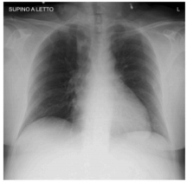 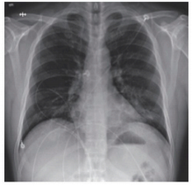 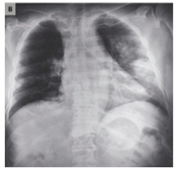

(a) ( b) (c)

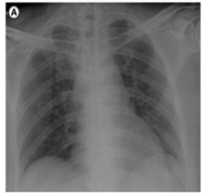 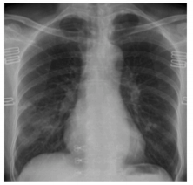 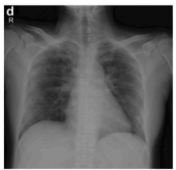

(d) (e) (f)

Fig. 1.different COVID images with different features and deformities (a) Cardio-vassal shadow [54], (b) Increasing left basilar opacity is visible, arousing concern about pneumonia [5], (c) Progressive infiltrate and consolidation [55], (d) Small consolidation in right upper lobe and GGO in both lower lobes [56], (e)right infrahilar airspace opacities [6], and (f) Progression of prominent bilateral perihilar infiltration and ill-defined patchy opacities at bilateral lungs [57].

**3.Contribution :**

proposed DarkCovidNet network:

as we know there are many uses of the YOLO algorithm one of which is classification and localization of objects and we also know the architecture that YOLO uses is Darknet 19. here Darknet 19 is a deep neural network and the word deep is for the size of the network means no of the layers are deep. the basic components in the Darknet 19 are noting but the CNN. A CNN structure has a convolution layer which helps to extract the different differents features from the input images this is done by different filters (also called kernels, which are typical of size 3,3 after standardization of Alexnet) along with that it has a pooling layer to reduce computation, and then fully connected layer which is a typical neural network, and by combining such layers a CNN model created .by using backpropagation algorithm we can adjust the internal weights to do a particular task like classification[58].

Instead of building a deep learning model from scratch, we modified DarkNet 19 model .because already DarkNet 19 model is a classifier and localization model which is used as a behind architecture for the YOLO system. Understanding the modified version of our model will be helpful if we look at the architecture of the DarkNet 19, so DarkNet 19 has 19 convolution layers as its name says and 5 max-pool pooling layers and has different filters, strides. Flow chart of DarkNet 19 is starting from c1-m1-c2-m2-triple c-m3-triple c- m4-five c-m5-five c (here c stands for convolution layer). Fig 2 represent the convolution maxpooling layers[59,60].

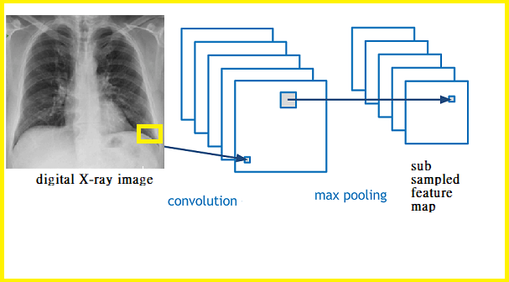

Fig. 2. representing the convolution maxpooling layers

The convolution sum formula for X input and H kernal is given as

$(X*H)(i,j)=\sum_{m=0}^{M-1}{(}\sum_{n=0}^{N-1}{\left(H(m,n)X(i-m,j-n)\right))=}\sum_{m=0}^{M-1}{(}\sum_{n=0}^{N-1}{\left(X(m,n)H(i-m,j-n)\right))}$ (1)

Where * is convolution operation .

LeakyReLu as a activation function used in DarkNet-19 ( which is having slope of 0.01 for negative side ) at last this model ends with the average pool and softmax layers and then the output .

In this study, we want to classify images with detail features or salient findings in images. the goal is to have a model which can learn small differences rather than very deep, like the ResNets. Fig 4 represent the proposed model. by modifying the architecture of DarkNet we proposed the model (DarkCovidNet) with 17 convolution layers each Darknet layer(DN) have one convolution layer then BatchNorm layer(batch normalization operation used to standardize the inputs, which practically present in undistributed fashion, there are other benefits for batch norm such as increasing stability and reducing the training time) then nonlinearity that is LeakyReLu(LeakyReLu is a little variation from the ReLu activation function it is used to avoid the problem form the dying neuron unlike the ReLu which lead 0 value for the negative part of the derivatives but here in leaky ReLu there is the small value present in the negative derivative side), and each 3 × Convolution layers further have the same setup three times in successive form. The Max pool method is the same exactly as there in Darknet -19 model, the use of the max pool is to reduce the computation complexity and also to downsize the input by taking maximum in the region of particular filter size. The visualization is shown in the Fig. 3.

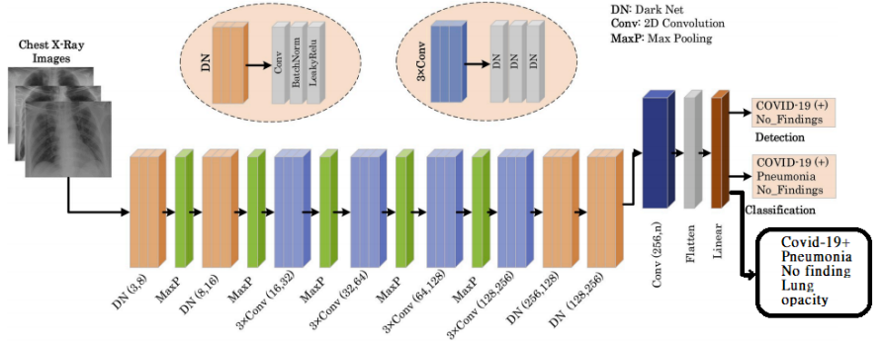

Fig. 3. Shows architecture of the proposed model (DarkCovidNet).

Our proposed model is capable of classisfing covind vs no finding in binary calss , and for multi calss covid vs no finding vs phenomia and further I have also implemented (my further contriution)for 4 classs also that is covid vs no findings vs lung opacity vs phenomia , the model consist of 1,164,434 Parameters for binary calss 1,164,773 for 3 calss ,1,165,112 parameters for 4 classs and we have used the famous Adam optimizer for weights updats , cross entropy loss function and selectewd learning rate as 0.003.the layers details of this model is given in the Table 1.

Table 1. This are the parameters for the binary classification /3 calss calssification / 4 calss classification

|  |  |  |  |
| --- | --- | --- | --- |
| Number of Layer | Layer Type | Output Shape | Number of Trainable Parameters |
| 1 | Conv2d | [8, 256, 256] | 216 |
| 2 | Conv2d | [16, 128, 128] | 1,152 |
| 3 | Conv2d | [32, 64, 64] | 4,608 |
| 4 | Conv2d | [16, 66, 66] | 512 |
| 5 | Conv2d | [32, 66, 66] | 4,608 |
| 6 | Conv2d | [64, 33, 33] | 18,432 |
| 7 | Conv2d | [32, 35, 35] | 2,048 |
| 8 | Conv2d | [64, 35, 35] | 18,432 |
| 9 | Conv2d | [128, 17, 17] | 73,728 |
| 10 | Conv2d | [64, 19, 19] | 8192 |
| 11 | Conv2d | [128, 19, 19] | 73,728 |
| 12 | Conv2d | [256, 9, 9] | 294,912 |
| 13 | Conv2d | [128, 11, 11] | 32,768 |
| 14 | Conv2d | [256, 11, 11] | 294,912 |
| 15 | Conv2d | [128, 13, 13] | 256 |
| 16 | Conv2d | [256, 13, 13] | 294,912 |
| 17 | Conv2d | [2, 13, 13] | 4,608 |
| 18 | Flatten | [338] | 0 |
| 19 | Linear | [2]/[3]/[4] | 678/1,017/1,356 |

**4.Resuts :**

we performed experiments to carry out the classification of covid 19 in binary, 3 classes with covid 19 vs pneumonia vs no findings, and 4 classes with covid 19 vs no findings vs lung opacity vs pneumonia, first we have trained the model with the training set which is consist of 1000 images and then validate or test that model with the 400 images each so that means training was done by 71% of data set and testing was done by 28.5% data set, the DarkCovidNet model was trained for the above 3 cases, and the results of this model are shown in **Fig 4**. that is the loss graph is given and the accuracy graph is given for different 3 cases , traing was done for 100 epoch each for the bianry class and for 3 class and traing was done for 20 epoch for the 4 class model.

**Fig 4** loss and accuracy in 3 different cases

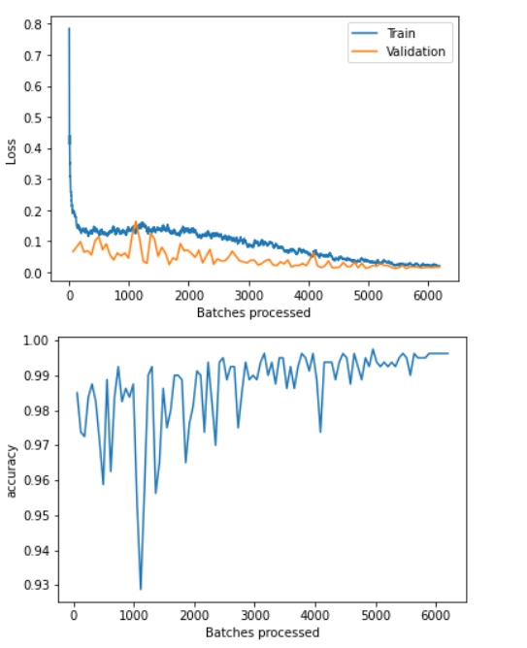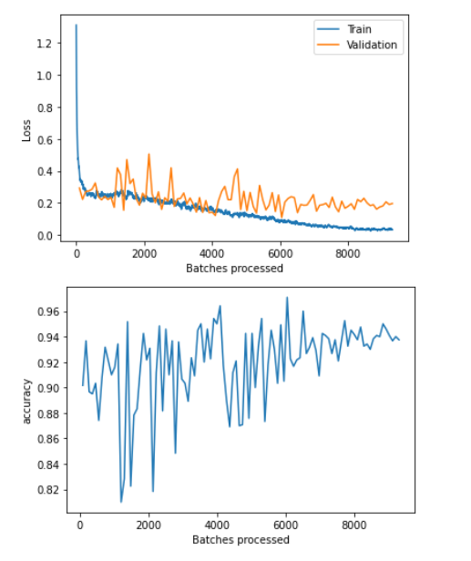 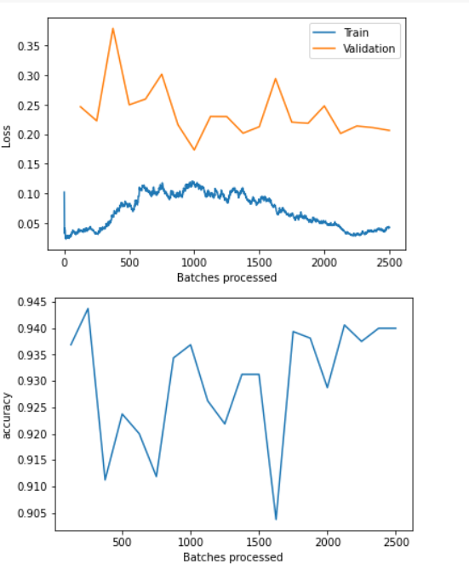

(a)binary class (b)3 class Covid 19vs No Finding vs Pneumonia (c) Covid 19 vs lung opacity vs No Finding vs Pneumonia

it's noted from **Fig 4**. that there is a significant increase in loss values at the beginning of the training, but it gets decreases substantially in the later stage of the training. and the further we can observe that there are sudden ups and down in the starting and it gets reduced in the end because of the over and overtraining in each epoch. further, we calculated the performance matrices to see different parameters and internal scores of the model, in **Fig 5**. you can see the confusion matrix corresponds to the different cases, and with that, you can also see the other scores such as sensitivity, specificity precision, F1-score, and accuracy in **Fig 6**.

Fig 5 confusion matrix

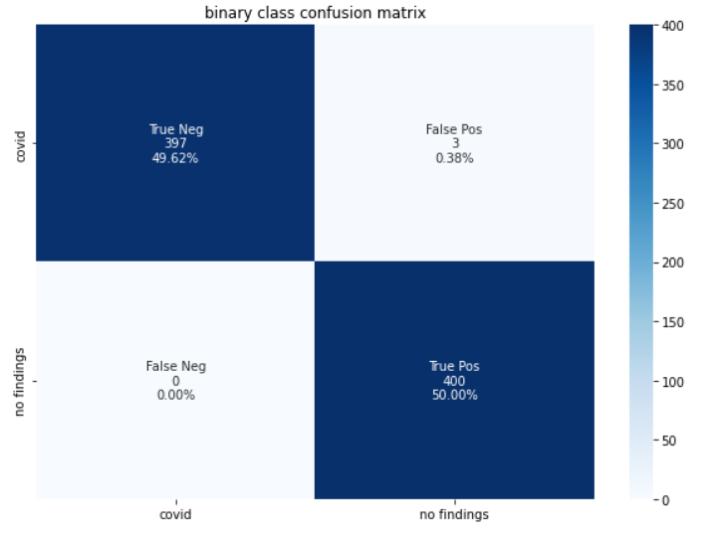 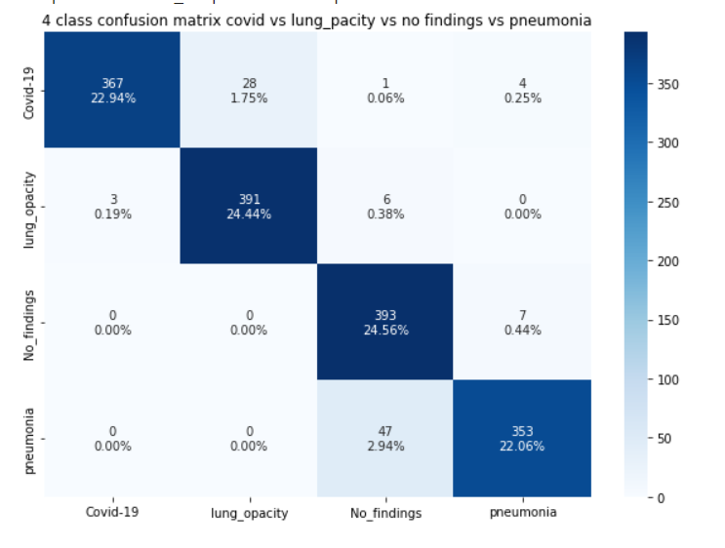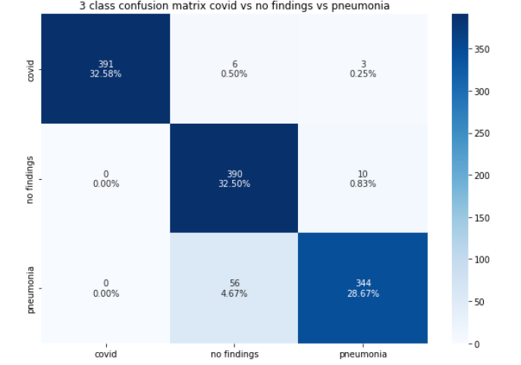

**Fig 6**

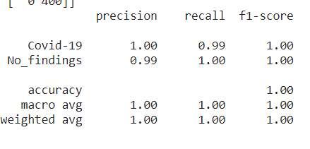 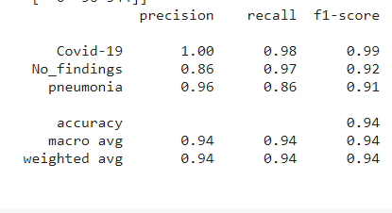 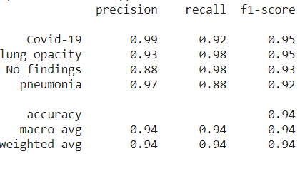

(a)binary class (b)3 class Covid 19vs No Finding vs Pneumonia (c) Covid 19 vs lung opacity vs No Finding vs Pneumonia

We can see accuracy here

**5.Conclusion :**

In this study, we proposed the deep learning based model to detect binary class Covid 19, 3 class (Covid 19vs No Finding vs Pneumonia), 4 class (Covid 19vs Lung Opacity vs No Finding vs Pneumonia) by using X-ray images. Our model is end to end fully automated and there is no need to manually extract feature.The author model was able to perform with the accuracy of 98.08% and 87.02% for binary class and multi class(3 class) respectively with the dataset of 127 covid X-ray images and the same model I implimented on binary , 3 class and 4 class will more data set was able to peform with the accuracy of 99.62% , 93.75% and 94% with the dataset of 1400 covid images so we can conclude that with more data for same epoch the accuracy of this model increased. The proposed by author were assessed by expert radiologists and is ready to be tested with large data base .

**Table 2** comparision of other methods with our proposed method

|  |  |  |  |  |
| --- | --- | --- | --- | --- |
| Study | Type of Images | Number of Cases | Method Used | Accuracy (%) |
| Ioannis et al. [43] | Chest X-ray | 224 COVID-19 (+) 700 Pneumonia 504 Healthy | VGG-19 | 93.48 |
| Wang and Wong [42] | Chest X-ray | 53 COVID-19 (+) 5526 COVID-19  (-) 8066 healthy | COVID-Net | 92.4 |
| Sethy and Behra [45] | Chest X-ray | 25 COVID-19 (+) 25 COVID-19 ( | ResNet50þ SVM | 95.38 |
| Hemdan et al. [41] | Chest X-ray | 25 COVID-19 (+) 25 Normal | COVIDX-Net | 90 |
| Narin et al. [44] | Chest X-ray | 50 COVID-19 (+) 50 COVID-19 ( | Deep CNN ResNet-50 | 98 |
| Ying et al. [46] | Chest CT | 777 COVID-19 (+) 708 Healthy | DRE-Net | 86 |
| Wang et al. [47] | Chest CT | 195 COVID-19 (+) 258 COVID-19 (-) | M-Inception | 82.9 |
| Zheng et al. [48] | Chest CT | 313 COVID-19 (+) 229 COVID-19 (-) | UNetþ3D Deep Network | 90.8 |
| Xu et al. [49] | Chest CT | 219 COVID-19 (+) 224 Viral pneumonia 175 Healthy | ResNet þ Location Attention | 86.7 |
| Proposed Study | Chest X-ray | 1400 COVID-19 (+) 1400 No-Finding | DarkCovidNet | 99.62 |
|  |  | 1400 COVID-19 (+) 1400 No-Finding  1400 pneumonia | DarkCovidNet |  |
|  |  | 1400 COVID-19 (+) 1400 No-Finding  1400 lung opacity  1400 pneumonia | DarkCovidNet |  |

# **6.References:**

[1] F. Wu, S. Zhao, B. Yu, et al., A new coronavirus associated with human respiratory disease in China, Nature 579 (7798) (2020) 265–269.

[2] C. Huang, Y. Wang, et al., Clinical features of patients infected with 2019 novel coronavirus in Wuhan, China, Lancet 395 (10223) (2020) 497–506.

[3] World Health Organization, Pneumonia of Unknown Cause–China. Emergencies Preparedness, Response, Disease Outbreak News, World Health Organization (WHO), 2020.

[4] Z. Wu, J.M. McGoogan, Characteristics of and important lessons from the coronavirus disease 2019 (COVID-19) outbreak in China: summary of a report of 72 314 cases from the Chinese Center for Disease Control and Prevention, Jama 323 (13) (2020) 1239–1242.

[5] M.L. Holshue, C. DeBolt, et al., First case of 2019 novel coronavirus in the United States, N. Engl. J. Med. 328 (2020) 929–936.

[6] W. Kong, P.P. Agarwal, Chest imaging appearance of COVID-19 infection, Radiology: Cardiothoracic Imaging 2 (1) (2020), e200028.

[7] T. Singhal, A review of coronavirus disease-2019 (COVID-19), Indian J. Pediatr. 87 (2020) 281–286. [8] Z.Y. Zu, M.D. Jiang, P.P. Xu, W. Chen, Q.Q. Ni, G.M. Lu, L.J. Zhang, Coronavirus disease 2019 (COVID-19): a perspective from China, Radiology (2020), https://doi. org/10.1148/radiol.2020200490. In press.

[9] J.P. Kanne, B.P. Little, J.H. Chung, B.M. Elicker, L.H. Ketai, Essentials for radiologists on COVID-19: an update—radiology scientific expert panel, Radiology (2020), https://doi.org/10.1148/radiol.2020200527. In press.

[10] X. Xie, Z. Zhong, W. Zhao, C. Zheng, F. Wang, J. Liu, Chest CT for typical 2019- nCoV pneumonia: relationship to negative RT-PCR testing, Radiology (2020), https://doi.org/10.1148/radiol.2020200343. In press.

[11] E.Y. Lee, M.Y. Ng, P.L. Khong, COVID-19 pneumonia: what has CT taught us? Lancet Infect. Dis. 20 (4) (2020) 384–385.

[12] A. Bernheim, X. Mei, et al., Chest CT findings in coronavirus disease-19 (COVID19): relationship to duration of infection, Radiology (2020), https://doi.org/ 10.1148/radiol.2020200463. In press.

[13] F. Pan, T. Ye, et al., Time course of lung changes on chest CT during recovery from 2019 novel coronavirus (COVID-19) pneumonia, Radiology (2020), https://doi. org/10.1148/radiol.2020200370. In press.

[14] C. Long, H. Xu, et al., Diagnosis of the Coronavirus disease (COVID-19): rRT-PCR or CT? Eur. J. Radiol. 126 (2020) 108961.

[15] H. Shi, X. Han, et al., Radiological findings from 81 patients with COVID-19 pneumonia in Wuhan, China: a descriptive study, Lancet Infect. Dis. 24 (4) (2020) 425–434.

[16] W. Zhao, Z. Zhong, X. Xie, Q. Yu, J. Liu, Relation between chest CT findings and clinical conditions of coronavirus disease (COVID-19) pneumonia: a multicenter study, Am. J. Roentgenol. 214 (5) (2020) 1072–1077.

[17] Y. Li, L. Xia, Coronavirus Disease 2019 (COVID-19): role of chest CT in diagnosis and management, Am. J. Roentgenol. (2020) 1–7.

[18] J.F.W. Chan, S. Yuan, et al., A familial cluster of pneumonia associated with the 2019 novel coronavirus indicating person-to-person transmission: a study of a family cluster, Lancet 395 (10223) (2020) 514–523.

[19] S.H. Yoon, K.H. Lee, et al., Chest radiographic and CT findings of the 2019 novel coronavirus disease (COVID-19): analysis of nine patients treated in Korea, Korean J. Radiol. 21 (4) (2020) 494–500.

[20] Edgar Lorente, COVID-19 pneumonia - evolution over a week. https://radiopaedia. org/cases/COVID-19-pneumonia-evolution-over-a-week-1?lang¼us.

[21] G. Litjens, T. Kooi, B.E. Bejnordi, A.A.A. Setio, F. Ciompi, M. Ghafoorian, C. I. Sanchez, A survey on deep learning in medical image analysis, Med. Image Anal. 42 (2017) 60–88.

[22] J. Ker, L. Wang, J. Rao, T. Lim, Deep learning applications in medical image analysis, Ieee Access 6 (2017) 9375–9389.

[23] D. Shen, G. Wu, H.I. Suk, Deep learning in medical image analysis, Annu. Rev. Biomed. Eng. 19 (2017) 221–248.

[24] O. Faust, Y. Hagiwara, T.J. Hong, O.S. Lih, U.R. Acharya, Deep learning for healthcare applications based on physiological signals: a review, Comput. Methods Progr. Biomed. 161 (2018) 1–13.

[25] F. Murat, O. Yildirim, M. Talo, U.B. Baloglu, Y. Demir, U.R. Acharya, Application of deep learning techniques for heartbeats detection using ECG signals-Analysis and Review, Comput. Biol. Med. 120 (2020) 103726.

[26] Y. LeCun, Y. Bengio, G. Hinton, Deep learning, Nature 521 (7553) (2015) 436–444.

[27] A. Krizhevsky, I. Sutskever, G.E. Hinton, Imagenet classification with deep convolutional neural networks, in: Advances in Neural Information Processing Systems, 2012, pp. 1097–1105.

[28] O. € Yıldırım, P. Pławiak, R.S. Tan, U.R. Acharya, Arrhythmia detection using deep convolutional neural network with long duration ECG signals, Comput. Biol. Med. 102 (2018) 411–420.

[29] A.Y. Hannun, P. Rajpurkar, M. Haghpanahi, G.H. Tison, C. Bourn, M.P. Turakhia, A.Y. Ng, Cardiologist-level arrhythmia detection and classification in ambulatory electrocardiograms using a deep neural network, Nat. Med. 25 (1) (2019) 65.

[30] U.R. Acharya, S.L. Oh, Y. Hagiwara, J.H. Tan, M. Adam, A. Gertych, R. San Tan, A deep convolutional neural network model to classify heartbeats, Comput. Biol. Med. 89 (2017) 389–396. [31] A. Esteva, B. Kuprel, R.A. Novoa, et al., Dermatologist-level classification of skin cancer with deep neural networks, Nature 542 (7639) (2017) 115–118, https:// doi.org/10.1038/nature21056. [32] N.C. Codella, Q.B. Nguyen, S. Pankanti, D.A. Gutman, B. Helba, A.C. Halpern, J. R. Smith, Deep learning ensembles for melanoma recognition in dermoscopy images, IBM J. Res. Dev. 61 (4/5) (2017), 5-1.

[33] Y. Celik, M. Talo, O. Yildirim, M. Karabatak, U.R. Acharya, Automated invasive ductal carcinoma detection based using deep transfer learning with whole-slide images, Pattern Recogn. Lett. 133 (2020) 232–239.

[34] A. Cruz-Roa, A. Basavanhally, et al., March). Automatic detection of invasive ductal carcinoma in whole slide images with convolutional neural networks, in: Medical Imaging 2014: Digital Pathology, vol. 9041, International Society for Optics and Photonics, 2014, p. 904103.

[35] M. Talo, O. Yildirim, U.B. Baloglu, G. Aydin, U.R. Acharya, Convolutional neural networks for multi-class brain disease detection using MRI images, Comput. Med. Imag. Graph. 78 (2019) 101673.

[36] P. Rajpurkar, J. Irvin, et al., Chexnet: Radiologist-Level Pneumonia Detection on Chest X-Rays with Deep Learning, 2017 arXiv preprint arXiv:1711.05225.

[37] J.H. Tan, H. Fujita, S. Sivaprasad, S.V. Bhandary, A.K. Rao, K.C. Chua, U. R. Acharya, Automated segmentation of exudates, haemorrhages, microaneurysms using single convolutional neural network, Inf. Sci. 420 (2017) 66–76.

[38] G. Ga al, B. Maga, A. Lukacs, Attention U-Net Based Adversarial Architectures for Chest X-Ray Lung Segmentation, 2020 arXiv preprint arXiv:2003.10304.

[39] J.C. Souza, J.O.B. Diniz, J.L. Ferreira, G.L.F. da Silva, A.C. Silva, A.C. de Paiva, An automatic method for lung segmentation and reconstruction in chest X-ray using deep neural networks, Comput. Methods Progr. Biomed. 177 (2019) 285–296.

[40] F. Caobelli, Artificial intelligence in medical imaging: game over for radiologists? Eur. J. Radiol. 126 (2020) 108940.

[41] E.E.D. Hemdan, M.A. Shouman, M.E. Karar, COVIDX-Net: A Framework of Deep Learning Classifiers to Diagnose COVID-19 in X-Ray Images, 2020 arXiv preprint arXiv:2003.11055.

[42] L. Wang, A. Wong, COVID-Net: A Tailored Deep Convolutional Neural Network Design for Detection of COVID-19 Cases from Chest Radiography Images, 2020 arXiv preprint arXiv:2003.09871. [43] Ioannis D. Apostolopoulos1, Tzani Bessiana, COVID-19: Automatic Detection from X-Ray Images Utilizing Transfer Learning with Convolutional Neural Networks, arXiv:2003.11617.

[44] A. Narin, C. Kaya, Z. Pamuk, Automatic Detection of Coronavirus Disease (COVID19) Using X-Ray Images and Deep Convolutional Neural Networks, 2020 arXiv preprint arXiv:2003.10849.

[45] P.K. Sethy, S.K. Behera, Detection of Coronavirus Disease (COVID-19) Based on Deep Features, 2020.

[46] Y. Song, S. Zheng, L. Li, X. Zhang, X. Zhang, Z. Huang, Y. Chong, Deep learning enables accurate diagnosis of novel coronavirus (COVID-19) with CT images, medRxiv (2020).

[47] S. Wang, B. Kang, J. Ma, X. Zeng, M. Xiao, J. Guo, B. Xu, A deep learning algorithm using CT images to screen for Corona Virus Disease (COVID-19), medRxiv (2020).

[48] C. Zheng, X. Deng, Q. Fu, Q. Zhou, J. Feng, H. Ma, X. Wang, Deep learning-based detection for COVID-19 from chest CT using weak label, medRxiv (2020), https:// doi.org/10.1101/2020.03.12.20027185.

[49] X. Xu, X. Jiang, C. Ma, P. Du, X. Li, S. Lv, et al., Deep Learning System to Screen Coronavirus Disease 2019 Pneumonia, 2020 arXiv preprint arXiv:200209334.

[50] M. Barstugan, U. Ozkaya, S. Ozturk, Coronavirus (COVID-19) Classification Using CT Images by Machine Learning Methods, 2020 arXiv preprint arXiv:2003.09424.

[51] X. Chen, L. Yao, Y. Zhang, Residual Attention U-Net for Automated Multi-Class Segmentation of COVID-19 Chest CT Images, 2020 arXiv preprint arXiv: 2004.05645.

[52] L. Lan, D. Xu, G. Ye, C. Xia, S. Wang, Y. Li, H. Xu, Positive RT-PCR test results in patients recovered from COVID-19, Jama 323 (15) (2020) 1502–1503.

[53] J.P. Cohen, COVID-19 Image Data Collection, 2020. https://github.com/ieee 8023/COVID-chestxray-dataset.

[54] Gallarato Gabriele, Demaria Paolo, Negri Alberto, Baralis Ilaria, Cerutti Andrea, Priotto Roberto, Violino Paolo, COVID-19:caso 56. https://www.sirm.org/202 0/03/21/COVID-19-caso-56/. [55] L.T. Phan, T.V. Nguyen, Q.C. Luong, T.V. Nguyen, H.T. Nguyen, H.Q. Le, Q. D. Pham, Importation and human-to-human transmission of a novel coronavirus in Vietnam, N. Engl. J. Med. 382 (9) (2020) 872–874.

[56] J. Lim, S. Jeon, H.Y. Shin, M.J. Kim, Y.M. Seong, W.J. Lee, S.J. Park, Case of the index patient who caused tertiary transmission of COVID-19 infection in Korea: the application of lopinavir/ritonavir for the treatment of COVID-19 infected pneumonia monitored by quantitative RT-PCR, J. Kor. Med. Sci. 35 (6) (2020).

[57] S.C. Cheng, Y.C. Chang, Y.L.F. Chiang, Y.C. Chien, M. Cheng, C.H. Yang, Y.N. Hsu, First case of coronavirus disease 2019 (COVID-19) pneumonia in taiwan, J. Formos. Med. Assoc. (2020).

[58] X. Wang, Y. Peng, L. Lu, Z. Lu, M. Bagheri, R.M. Summers, Chestx-ray8: hospital scale chest x-ray database and benchmarks on weakly-supervised classification and localization of common thorax diseases, in: Proceedings of the IEEE Conference on Computer Vision and Pattern Recognition, 2017, pp. 2097–2106.

[59] J. Redmon, A. Farhadi, Yolo9000: Better, Faster, Stronger, 2017 arXiv preprint.

[60] K. He, X. Zhang, S. Ren, J. Sun, Deep residual learning for image recognition, in: Proceedings of the IEEE Conference on Computer Vision and Pattern Recognition, 2016, pp. 770–778.

[61] R.R. Selvaraju, M. Cogswell, A. Das, R. Vedantam, D. Parikh, D. Batra, Grad-cam: visual explanations from deep networks via gradient-based localization, in: Proceedings of the IEEE International Conference on Computer Vision, 2017, pp. 618–626.

[62] H.X. Bai, B. Hsieh, et al., Performance of radiologists in differentiating COVID-19 from viral pneumonia on chest CT, Radiology (2020), https://doi.org/10.1148/ radiol.2020200823. In press.

[63] Chest X-ray images (pneumonia). https://www.kaggle.com/paultimothymooney/c hest-xray-pneumonia.

[63] Chest X-ray images (pneumonia). https://www.kaggle.com/paultimothymooney/c hest-xray-pneumonia.